**QUESTION PAPER**

**GENERATION**

**WITH CHAT FEATURE**

**PROJECT BY**

**ROSHINI VARADA (26)**

**VATTEM SAI PAVAN (27)**

**TEJASWI GUTURU (16)**

**KARISHMA YALLANKI (29)**

**CONTENTS OF PROJECT REPORT**

**CONTENT PAGE.NO**

**TITLE 1**

**CONTENTS OF PROJECT REPORT 2**

**PROJECT PROPOSAL AND PLAN 4**

* + 1. **MOTIVATION**
    2. **SIGNIFICANCE OF PROJECT**
    3. **SCOPE OF PROJECT**
    4. **OBJECTIVES**
    5. **SYSTEM FEATURES**
    6. **BACKUP IDEA**

1. **INTRODUCTION 6**
2. **EXISTING IDEA 6**
3. **OBJECTIVE 6**
4. **UML DIAGRAMS 7**

**I)CLASS DIAGRAM 7**

**II)SEQUENCE DIAGRAM 8**

1. **TESTING 9**
2. **SOFTWARE REQUIRED 9**
3. **IMPLEMENATION 9**
   1. **INCREMENT 1 9**
   2. **INCREMENT 2 10**
   3. **INCREMENT 3 11**
4. **FEATURES IN APP 11**
5. **DEPLOYMENT 11**
6. **PROJECT OUTPUT 12**
   1. **WEB APP OUTPUT 12**
   2. **MOBILE APP OUTPUT 27**
7. **FUTURE SCOPE 39**
8. **CONCLUSION 39**
9. **PROJECT MANAGEMENT 39**
   1. **RESPONSIBILITIES 39**
   2. **TIME TAKEN 40**
10. **REFERENCES 40**

**PROJECT GOAL AND OBJECTIVES:**

* **MOTIVATION**

Generally, online examination faces many security threats such as impersonation, third party assistance or even interaction with other exam takers in the hall. Existing systems do provide efficient identity check by manual verification of the invigilator in the examination hall which avoids impersonation but may fail to check for threats during the course of exam. Also, one of the main challenges of an exam is to maintain standards of the question paper based on test taker’s capability.

* **SIGNIFICANCE OF PROJECT:**

This system would allow the online examination to take place in remote location and eliminates the necessity of an invigilator. Moreover, this system eliminates creating question papers manually which saves time, resources and human effort. Also, this system prevents paper leaks as transportation of paper is prevented.

* **SCOPE OF PROJECT**

The proposed system seeks to implement question paper generator as the main element of the project and also to enable chat feature with this element.

* **OBJECTIVES**

The objective of the project is to create a system is to create a suitable difficulty level question paper for the test taker.

And make the whole application user friendly with lots of features that will help user to understand the application better and improve his academics well.

* **SYSTEM FEATURES**

1. Question paper generation system would create a question paper based on the input of the difficulty level.
2. Chat systems helps students to communicate freely and other features in the application helps students to interact with other students and the institution well.

* **BACKUP IDEA:**

Question paper generation system where the question paper will be automatically generated which helps in avoiding question paper leaks and eliminates to carry question papers. It also helps to maintain the standards of the question papers because it helps to maintain question paper standards it also helps to cover vast syllabus. It provides unbiased results and reduces human effort.

1. **INTRODUCTION:**

Question paper generation app is an application that helps to generate a question paper automatically from the data base. This application usually can be used by academic institutions and this application comes with various features and one of the main feature among them is chat feature, which helps the users of this application to communicate among them.

This application developed using various software and main software is angular 8 framework and node.js and firebase.

1. **EXISTING IDEA:**

Generally institutions conduct in class exams and do not depend much on online based exams, most of the times institutions give out the link for exam and ask students to take out the exam, it only comes with question paper that is static and do not contain evaluation in it.

Later on it developed to automatic question paper based on adoptive mechanism and evaluation feature.

1. **OBJECTIVE:**

To make it easy for academic institutions for conducting exams and evaluating tests easily with pre created database and to improve the communication between students and institution and also to make the student access the test with ease.

This app is mainly developed in order to help out students and academic institutions to carry out their academic work without any difficulties during pandemic effects.

1. **UML DIAGRAMS:**

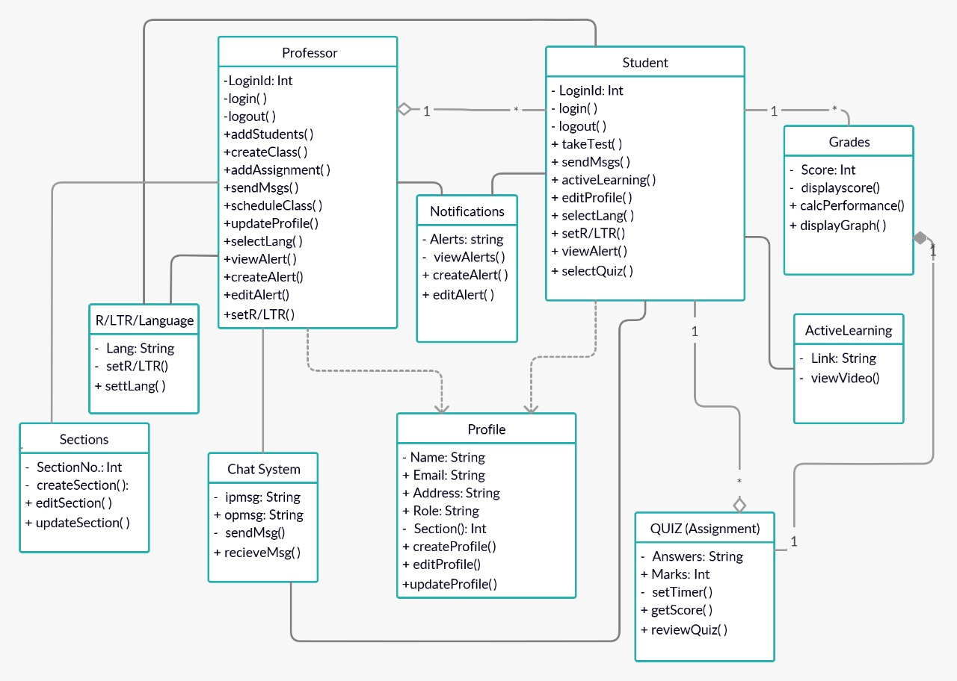

**1)Class diagram**

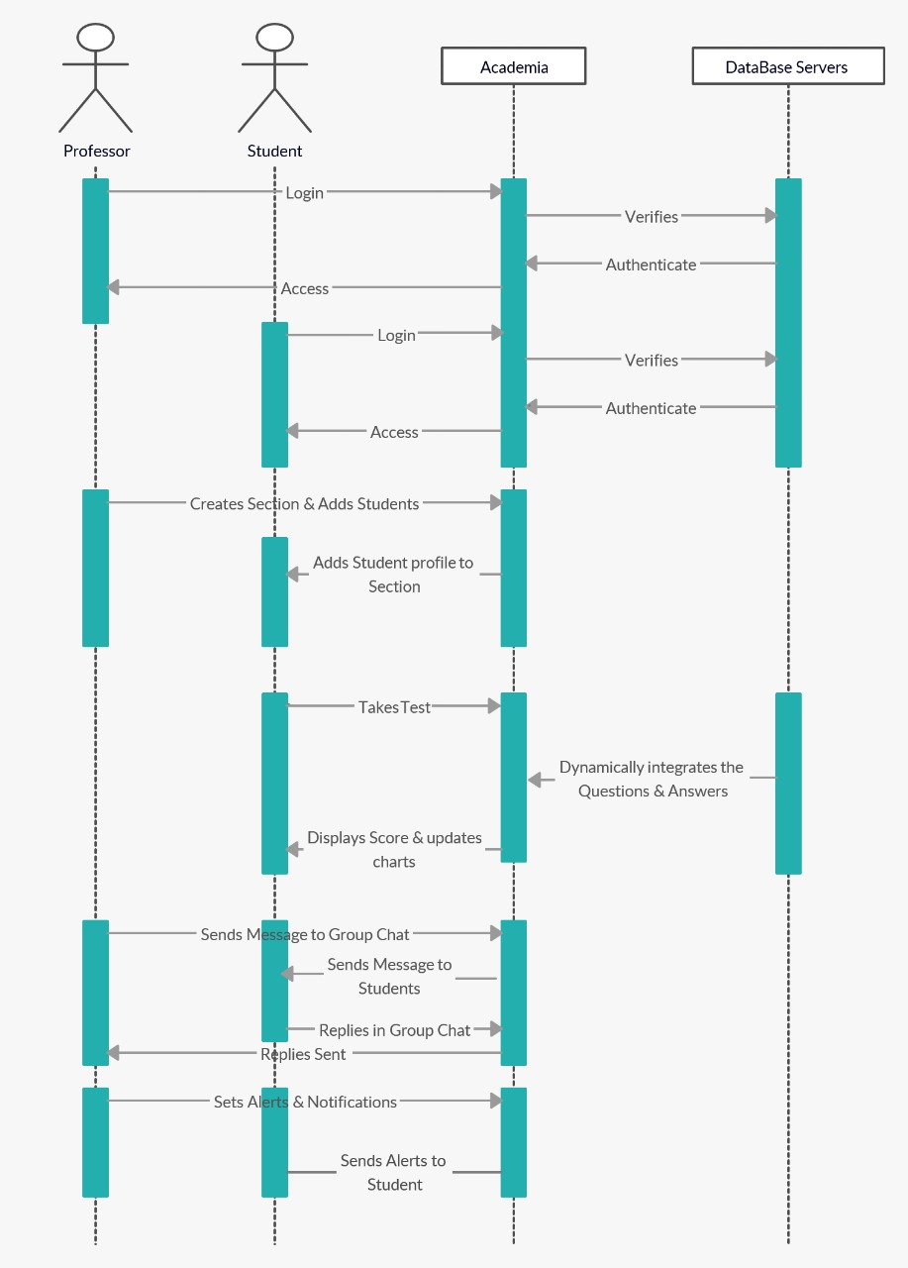

**2) Sequence diagram**

1. **TESTING:**

We have implemented unit testing for this project and the test cases and the results can be viewed through the following link

<https://github.com/RoshiniVarada/ASE_PROJECT/blob/master/unit%20testcases.xlsx>

1. **SOFTWARE REQUIRED:**

* Node.js
* Angular 8
* Firebase account
* Bootstrap 4
* Socket programming
* Heroku
* Android studio
* Babel edit
* Mongo DB
* Cordova

1. **IMPLEMENATION:**

We started this app from scratch with the intention to generate a question paper and along with lots of features that make the application user friendly communicable with other users.

**6.1 INCREMENT 1:**

* We used node.js angular 8 to create the base of this project, we created a project using node.js and developed it with the help of angular 8 and bootstrap.
* First, we created a database using firebase and later we have developed our app using angular 8, we have created many components for many features of application.
* First of all we created secured user authentication using firebase, which allows only authorized users to access the application.
* There is also feature of logging in/signing up using social media accounts in this application, we also used firebase for this.
* We created basic UI for user profile and added some features like user searching using based on name and user searching based on age.

**6.2 INCREMENT 2:**

* Next we developed automatic web scraping from internet for question paper generation, so whenever user requests to write a test. The questions will come up from website that requested by the admin of the test.
* We integrated firebase database into the application which contains user details depending on his classes and sections.
* We have integrated cordova native into the application using angular 8.
* We deployed our app into android mobile using the software called android studio.
* We have generated an APK which will help this app to run in the andoid mobile.

**6.3 INCREMENT 3:**

* We have used Bootstrap 4 to develop entire UI of the application, which is a responsive UI.
* We integrated socket programming into the application for chat feature which allows users to communicate among themselves.
* We have developed a forum section in the application which contain academic materials that students can learn from, it is dynamic and responsive as the forum is filled up with materials of courses that chose by student which differs from student to student.
* The number of questions in a test are also changes dynamically as user needed.
* We have included notifications and alert messages to student in this application which is developed using angular 8.
* We have created various features like searching for user based on the age, based on the name using angular 8.
* We used ng charts to create statistics of user/student performance in various tasks.
* We developed screen mirroring feature and language choosing option with angular 8.we also used babel software in language changing feature.
* We have deployed our app into web using heroku.
* We have integrated a micro service as chat service in heroku.
* To bring the data from the websites and also to call the database data we used an API, which brings the data in JSON format.
* We used mongo DB to store the user data.
* This is how we implemented main features of our application, you can find the code for all the development of the core of the application and feature development in the link below.

1. **FEATURES IN APP:**

* Secure authentication
* Authentication using social media
* Alerts
* Notifications
* Chat section
* Automatic question paper generation
* Language change up to 8 major languages
* Responsive UI for web and mobile app
* User friendly UI
* Native mobile app
* Publicly hosted web app
* Student performance statistics using ng charts
* User search using age and name
* Left to right and vice versa altering of app.

1. **DEPLOYMENT:**

* Created both web app and mobile app with same core base, two main API s are created in project they are.,

1. API for chat server
2. Question paper generation

* the API s created are dynamic in nature with subject name and number of questions as input
* web app is deployed in heroku and the url is as follows,

**https://academia12.herokuapp.com/sign-in**

* the mobile app is developed using apache cordova 8.0 and the link for apk is as follows,

<https://github.com/RoshiniVarada/ASE_PROJECT/tree/master/Review-3>

* source code and application output links are down below,

<https://github.com/RoshiniVarada/ASE_PROJECT/tree/master/Review-3>

1. **OUTPUT OF APPLICATION:**
   1. **WEB APP OUTPUT:**

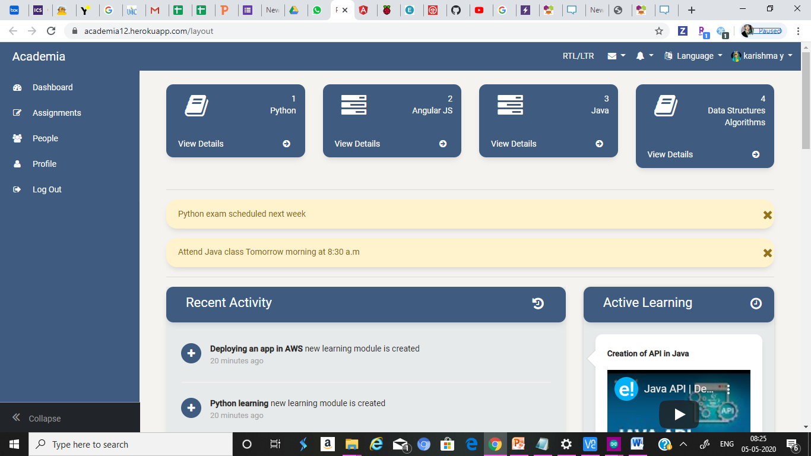

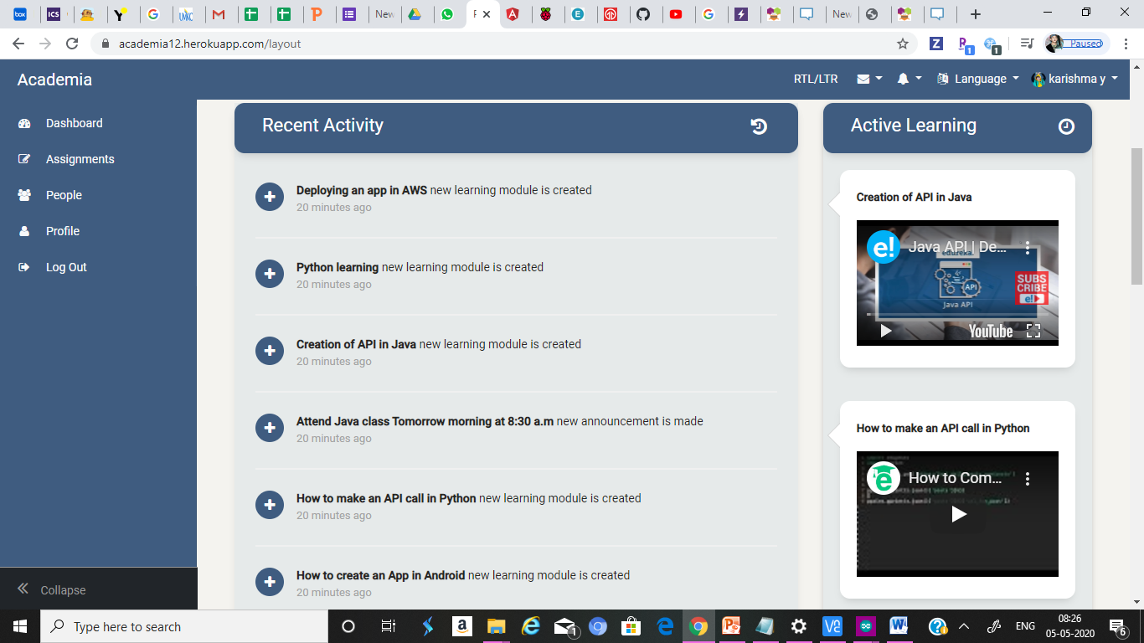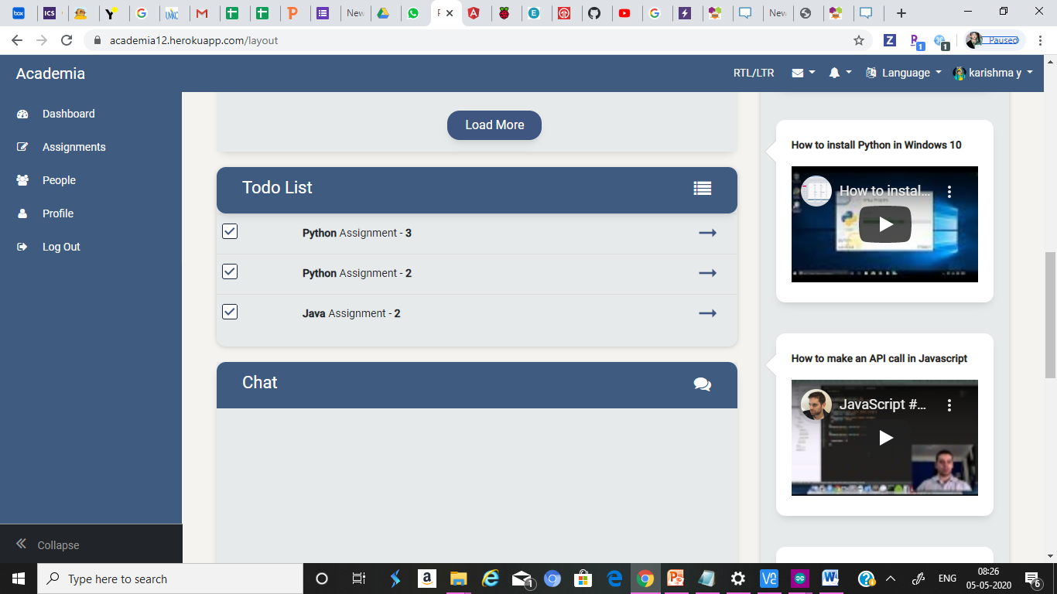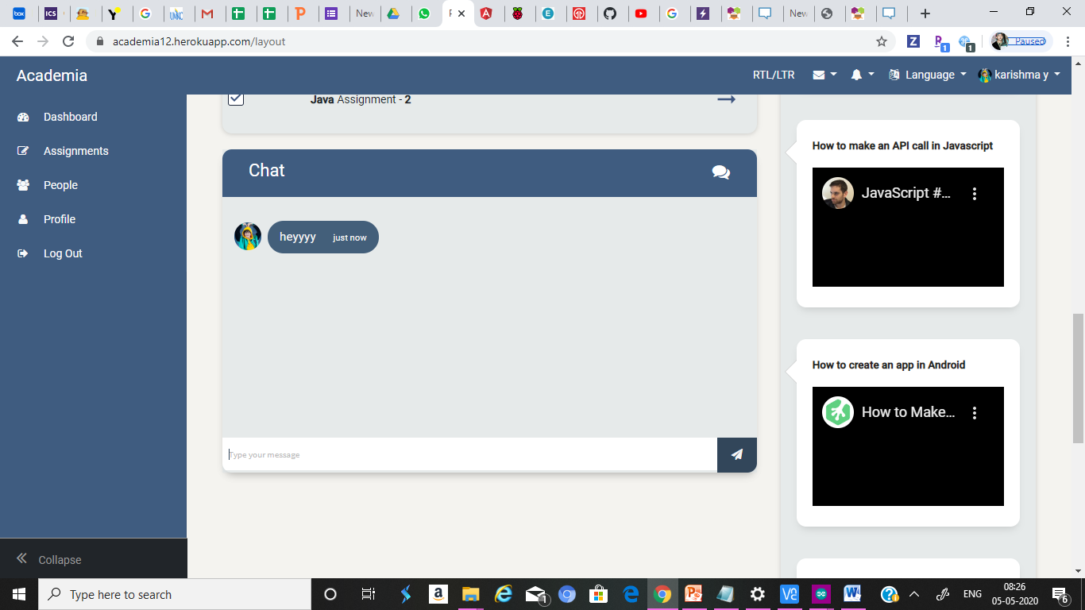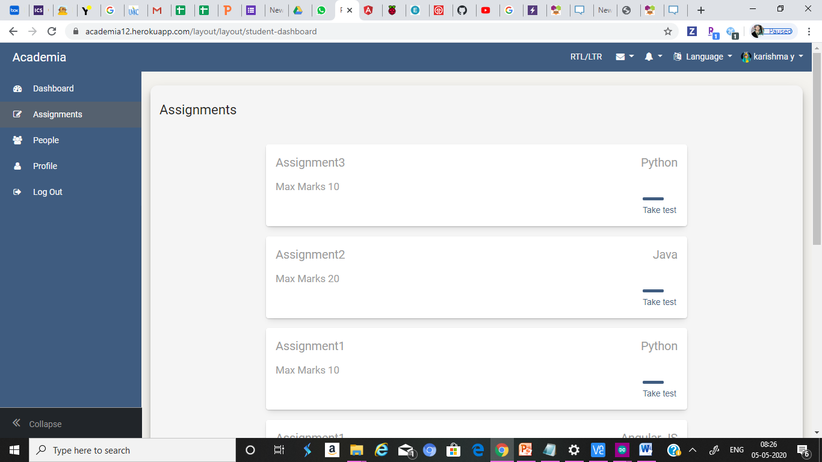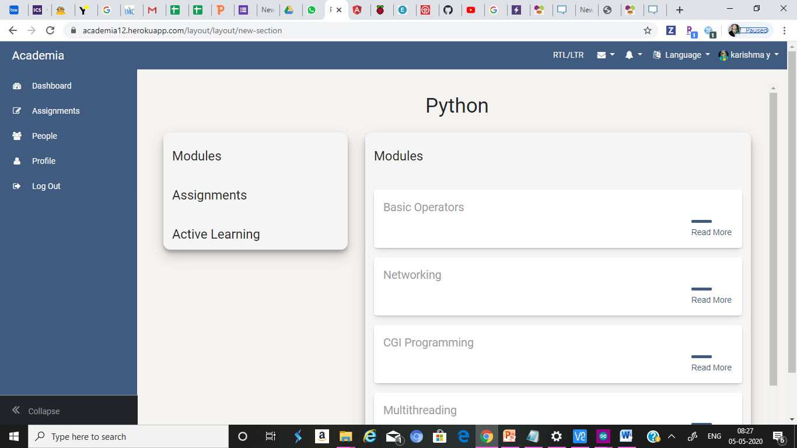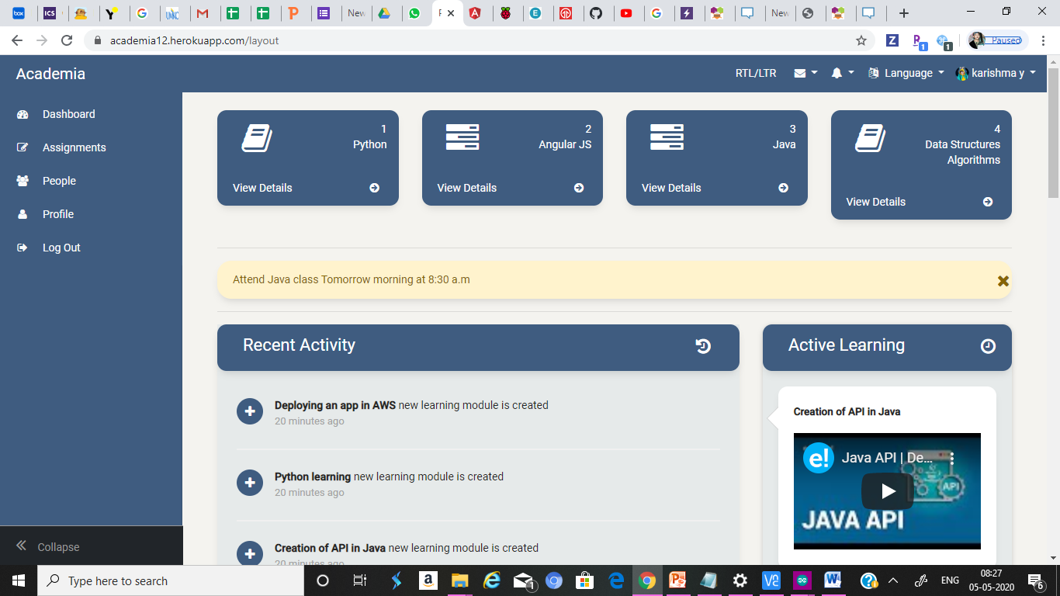

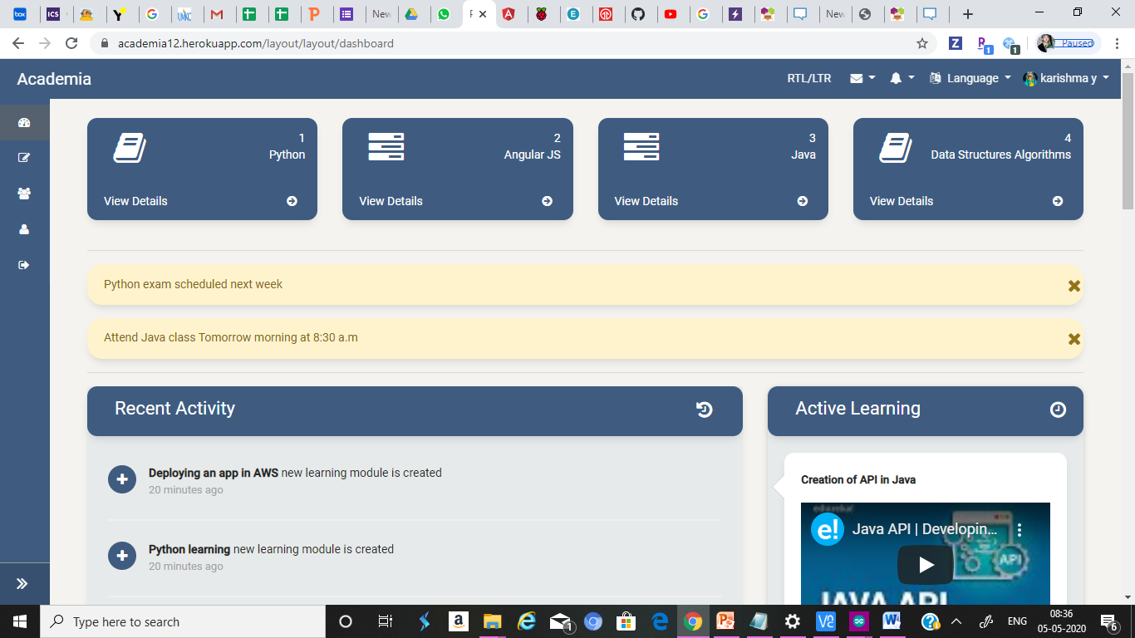

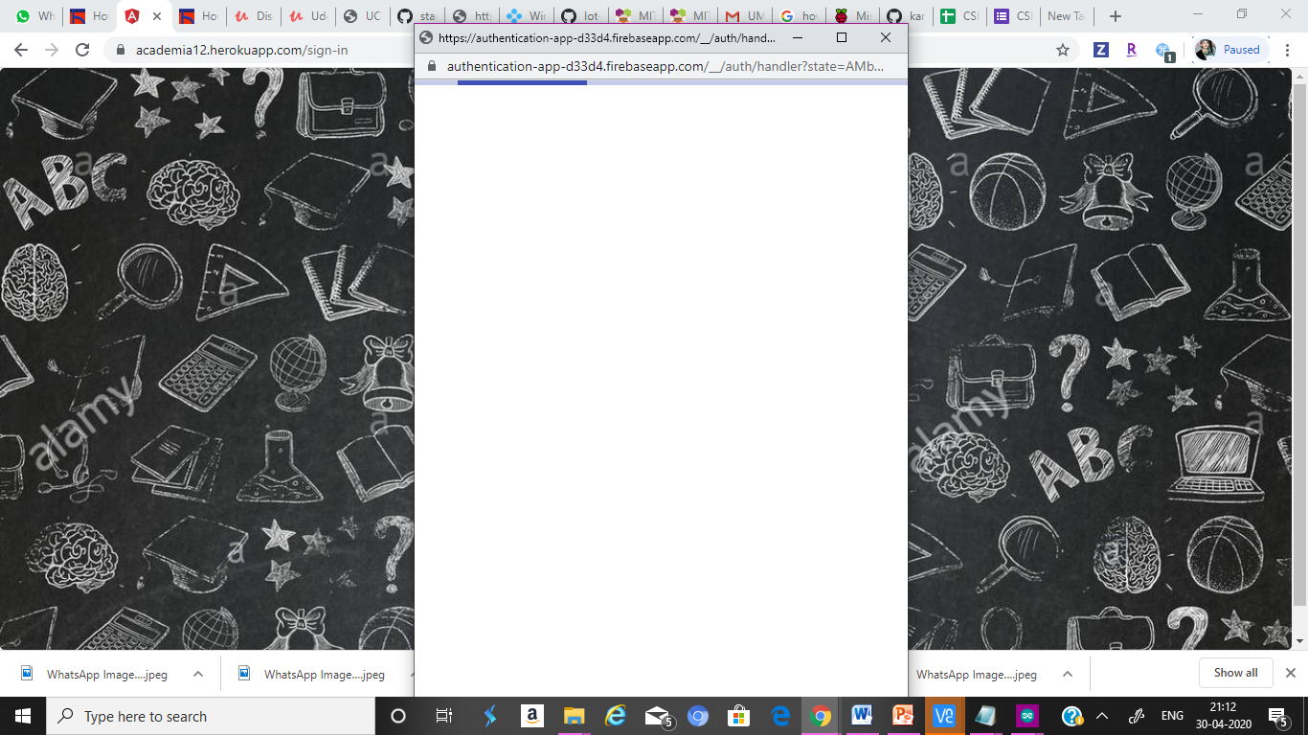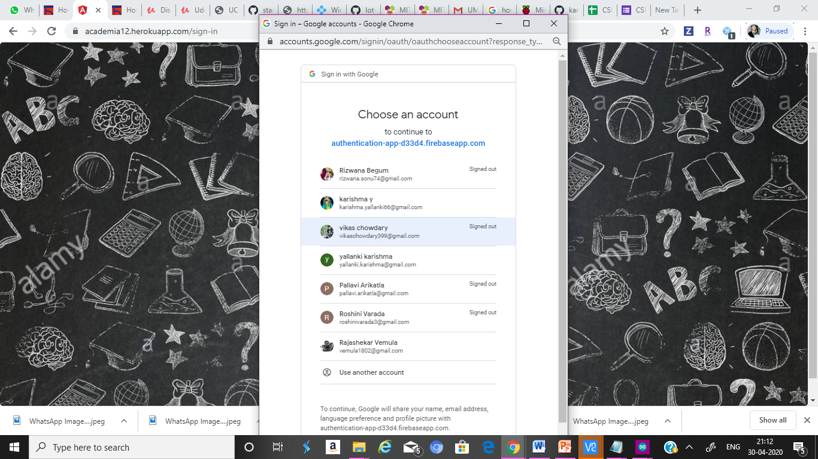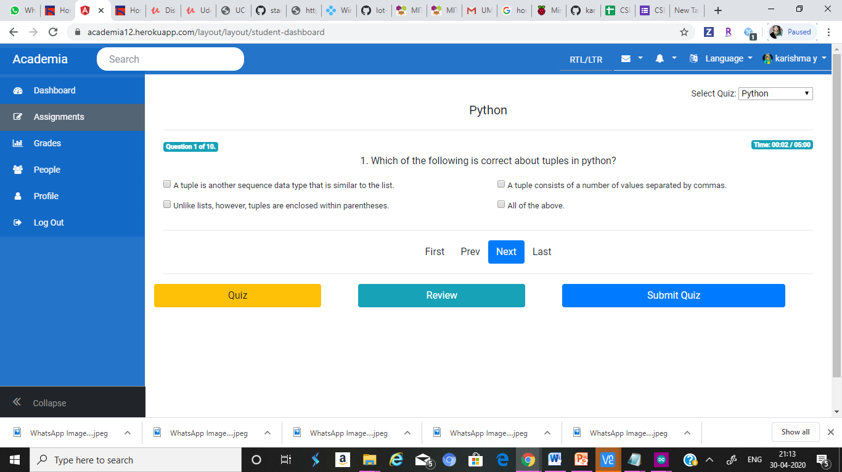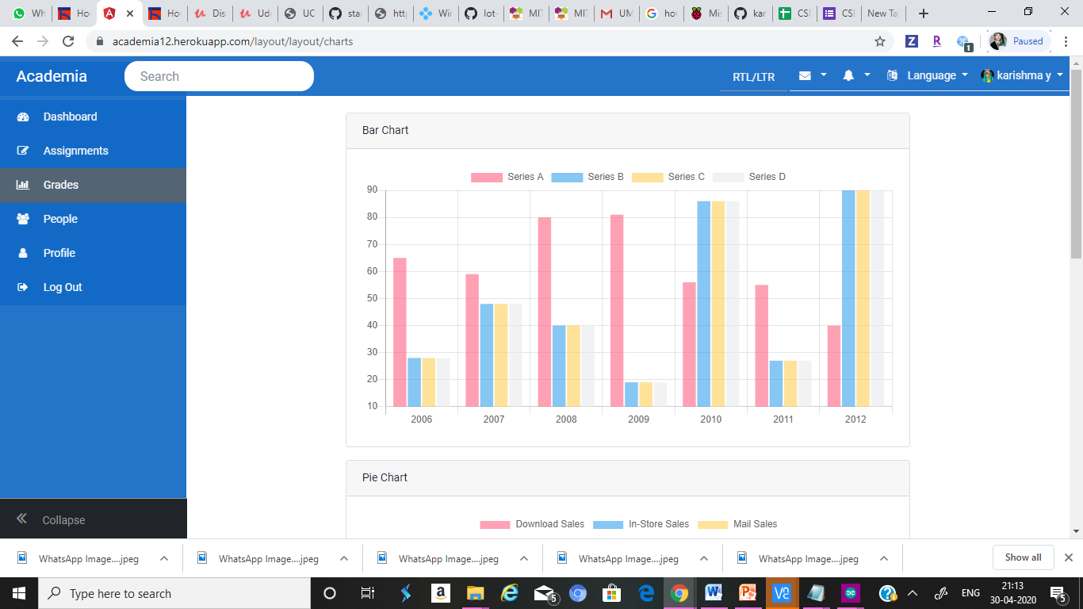

* 1. **MOBILE APP OUTPUT**

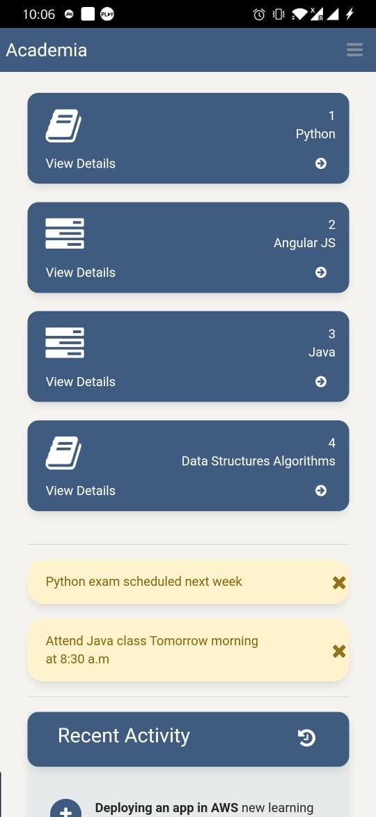**:**

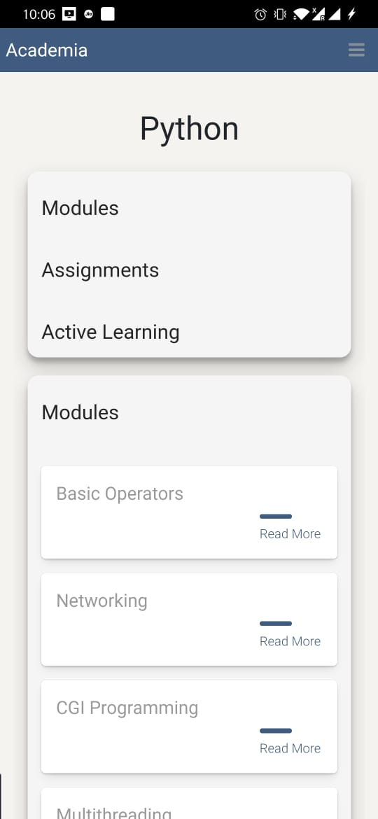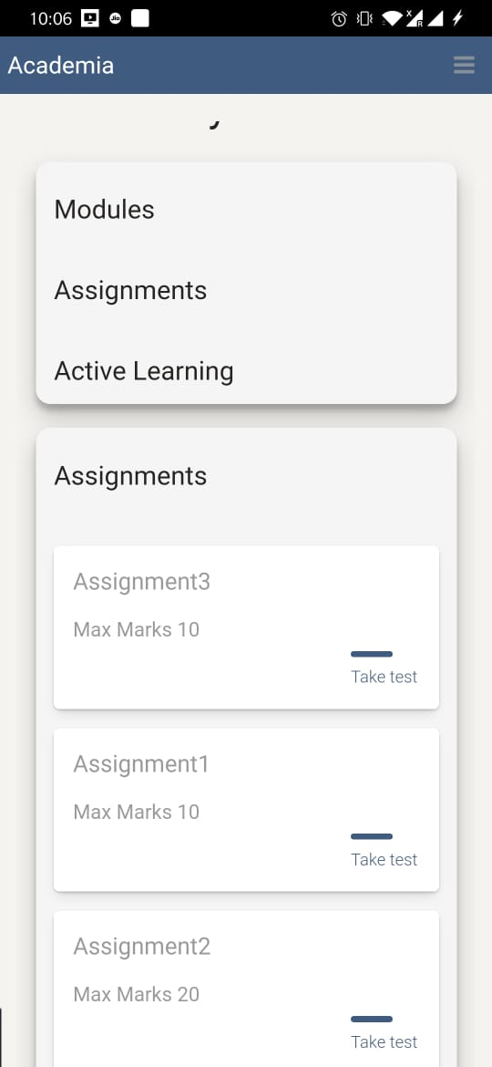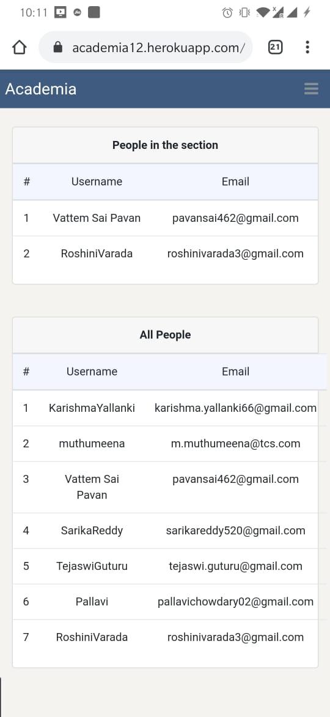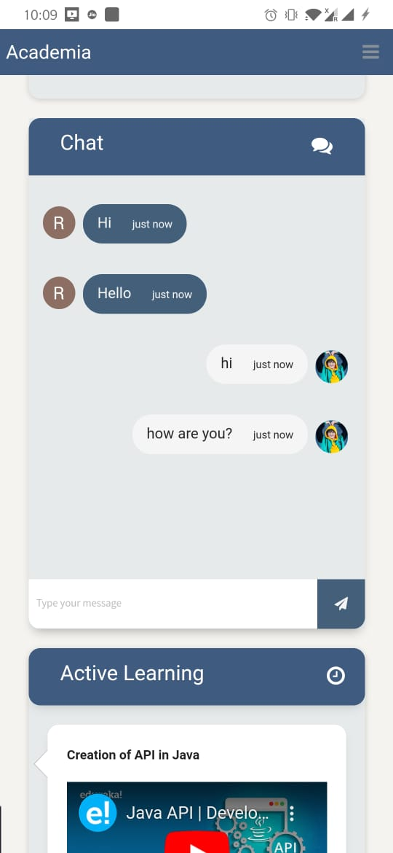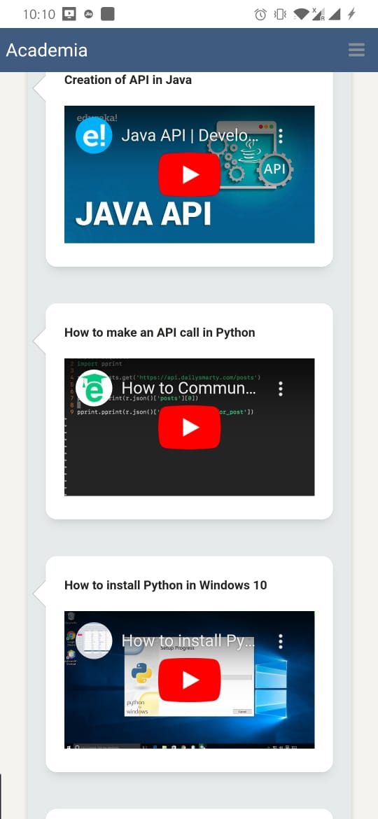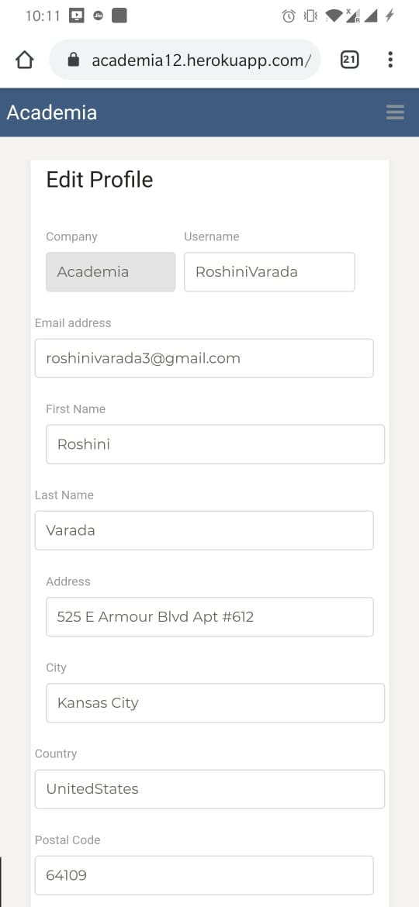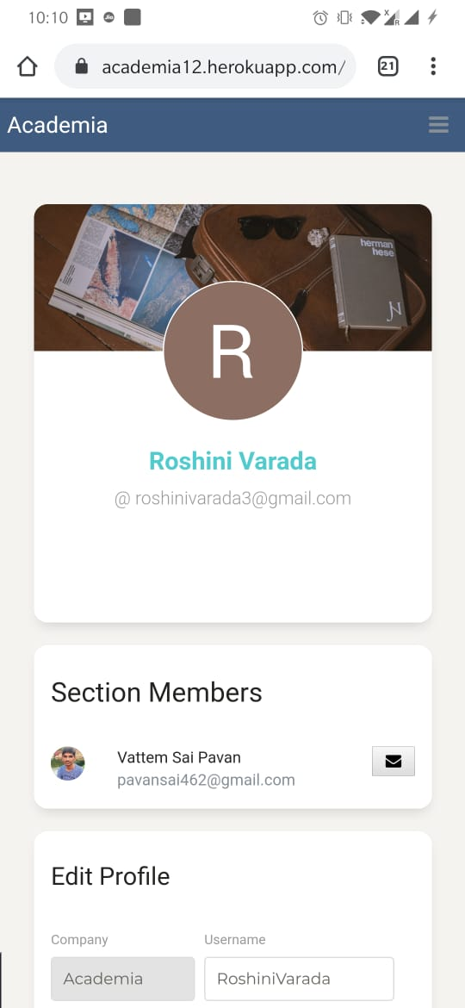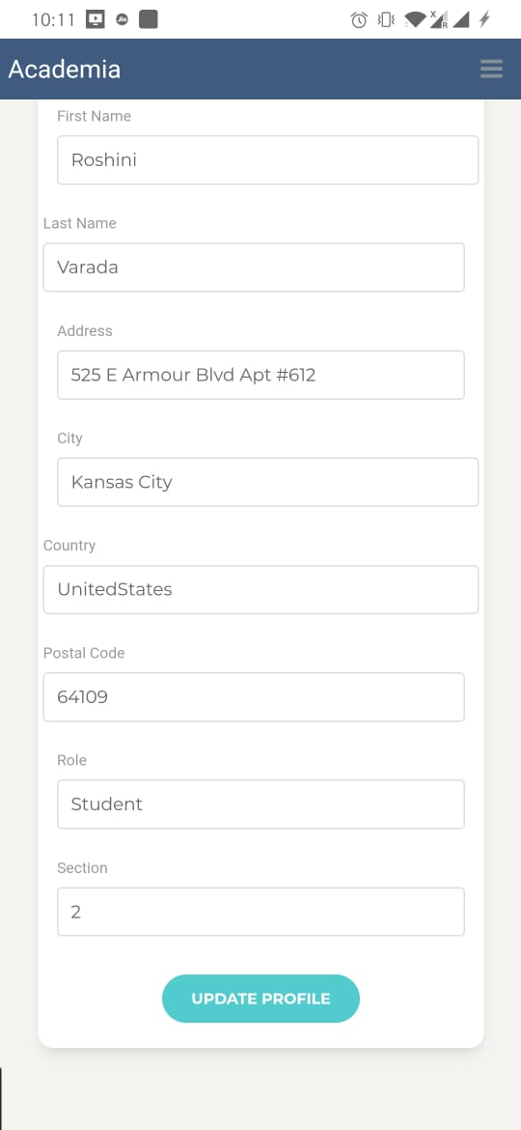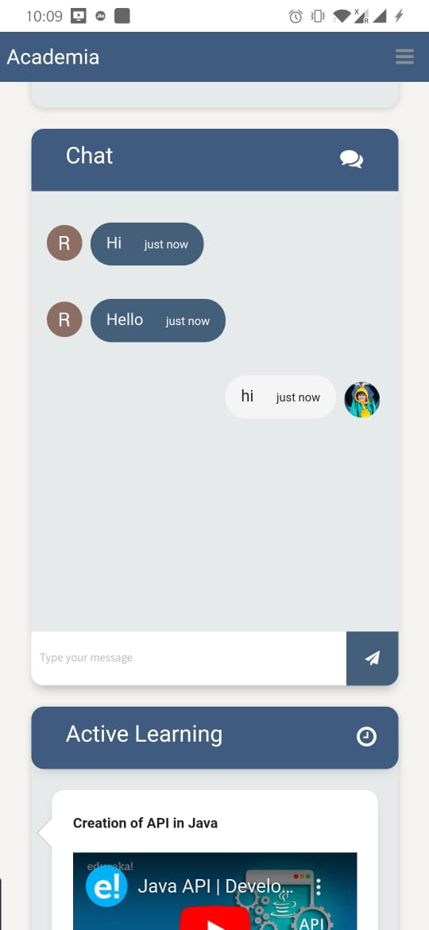

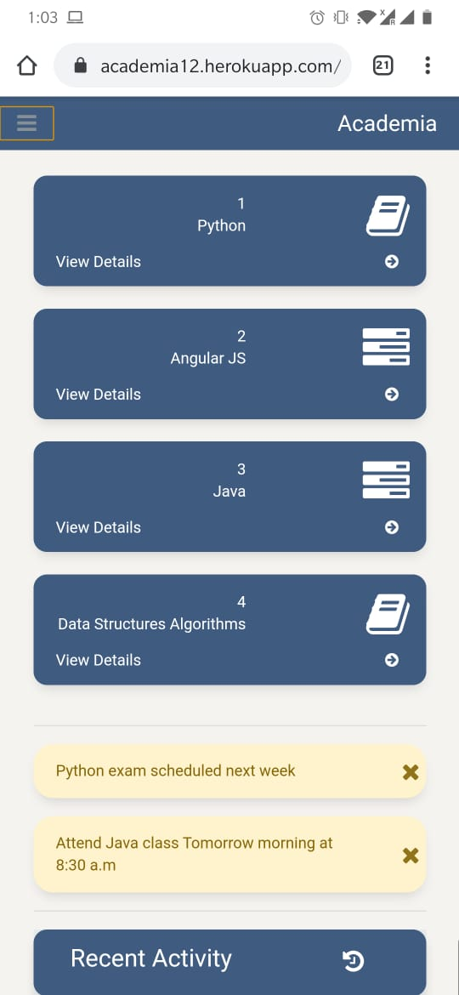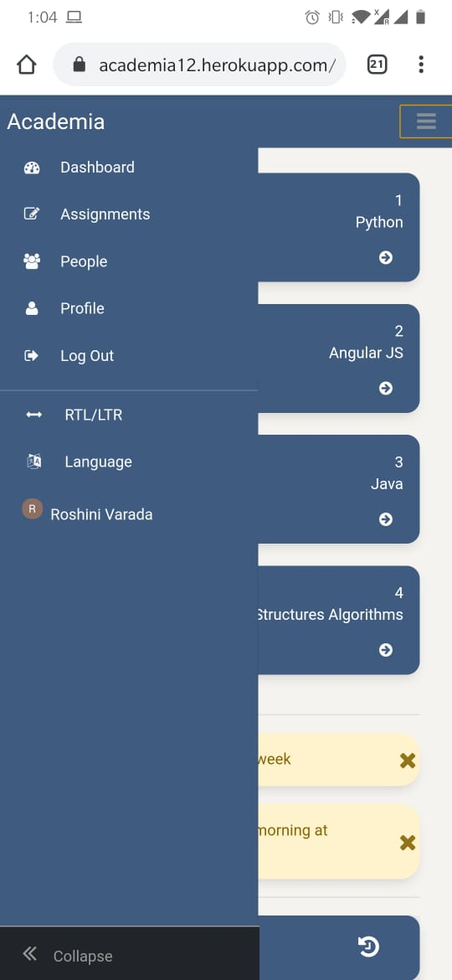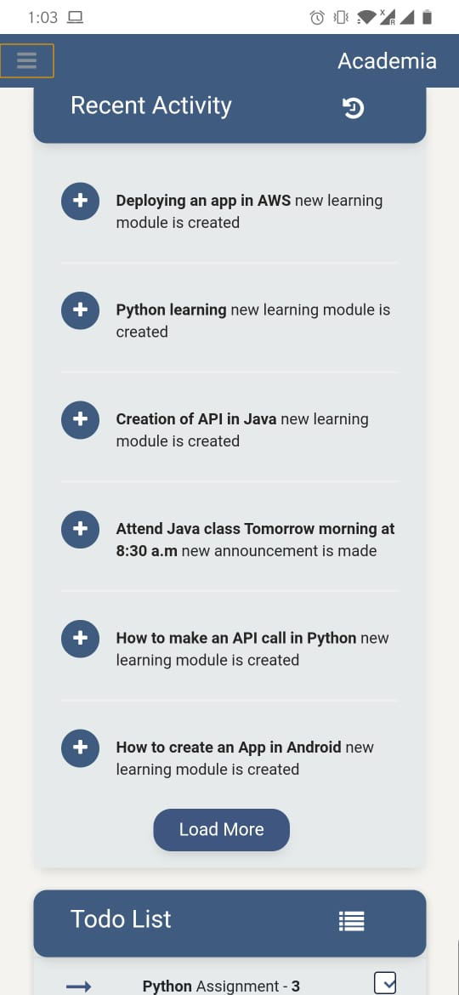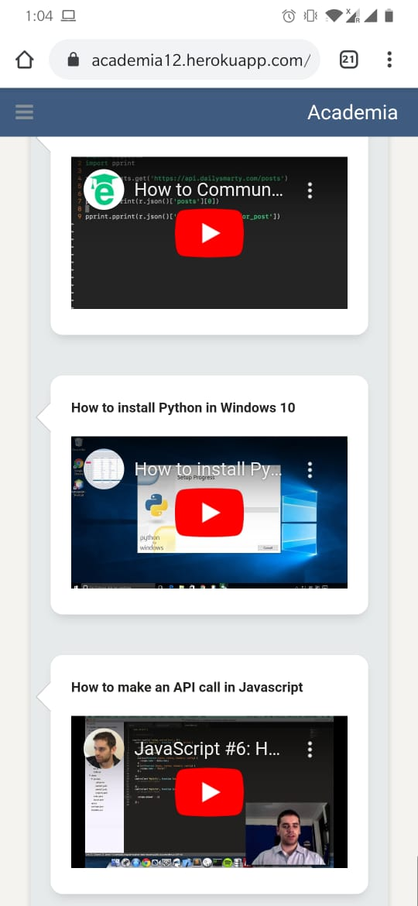

1. **FUTURE SCOPE:**

* This application can be further divided into a strict exam based platform by introducing face tracking system and also voice tracking system.
* We can develop this application by increasing number of languages that this app can be available in.
* We also can integrate this into official websites of institutions to access it with more ease.

1. **CONCLUSION:**

* In this project we learned how to create native apps and how to develop apps using angular 8 and introducing different features into the application and we learned how to use database systems and we learned how the software engineering works with all these platforms in various ways.
* We learned how web apps developed and how mobile apps are developed and what are the main advantages of software engineering and how various frameworks and platforms play their roles in software engineering and how they are connected with each other.

1. **PROJECT MANAGEMENT:**

**RESPONSIBILITIES:**

App development and apk creation: roshini varada.

API and services and database creation: vattem sai pavan

UI & UX: Tejaswi guturu.

UML diagrams and documentation: karishma yallanki.

**TIME TAKEN:**

* One week for planning.
* 3 days to generate data scraping and app development and including services and apk generation and deploying onto mobile phone.
* 3 days for UI.
* 2 day to design UML diagrams and write a report.

1. **REFERENCES:**

<https://cordova.apache.org/docs/en/latest/guide/cli/>

<https://docs.mongodb.com/guides/server/introduction/>